CAARI 2018- Report

Organising institution: University of North Texas, Sandia National Laboratories, and Los Alamos National Laboratory

Venue: Gaylord Texan Resort in Grapevine, Texas, USA

Date: August 12th - 17th, 2018

Description.

The Conference on Application of Accelerators in Research and Industry (CAARI – 2018) brings together scientists, engineers, professors, physicians and students from all over the world who use particle accelerators in their research and industrial applications. Each year the Topic Areas are reviewed and updated to reflect current research interests.
Iva Bogdanović Radović gave an invited talk in the session Cultural Heritage/Forensic Science titled: “Application of MeV SIMS for forensic document examination”.

Photos.
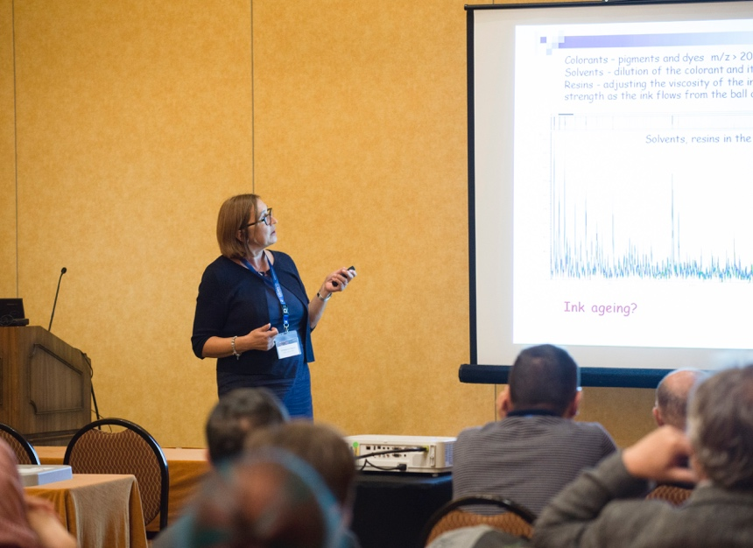

Report prepared by: Iva Bogdanović Radović

