Dissemination event- Report

Organising institution: Sheffield Hallam University (UK), Lodz University of Technology (Poland), University of Latvia (Latvia)

Venue: 1st Conference in translational Forensics in Lisbon

Date: 20th -23rd November 2017

Description.

The I International Caparica Conference in Translational Forensics was organized in Lisbon (http://www.forensics2017.com/ ). The Conference aims to connect in a transversal way all of us involved in Forensics with the objective of join together as many forensic disciplines as possible. The idea is to share the latest advances in forensic research and forensic technology as well as to report on their implementation in real cases

The following MULTIFORESEE members gave talks presenting key topics and activities of the Action:
- Prof.dr Simona Francese (UK)- plenary talk
- Prof. Janis Spigulis (Latvia) – oral presentation
- Prof. Iwona Szynkowska (Poland)- keynote speaker.

Photos.

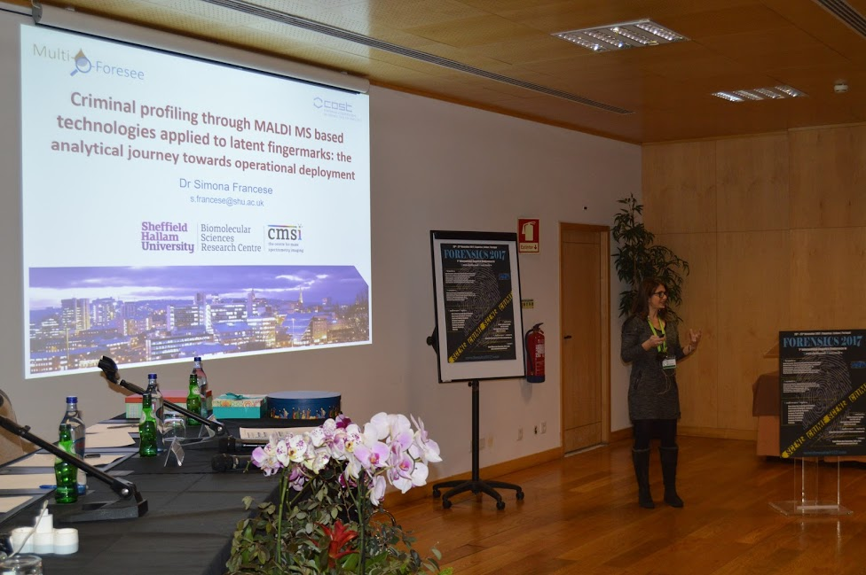

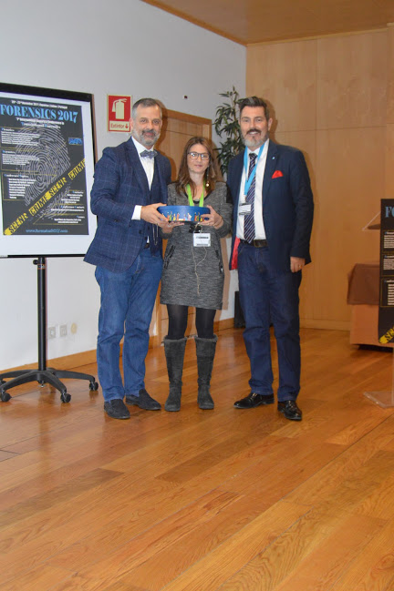
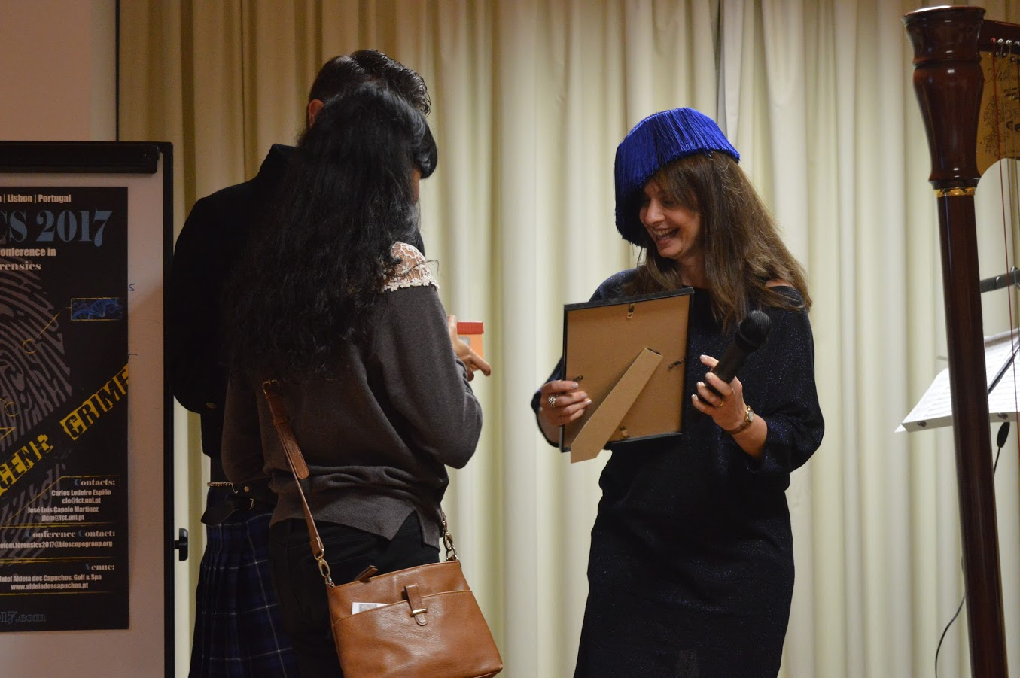

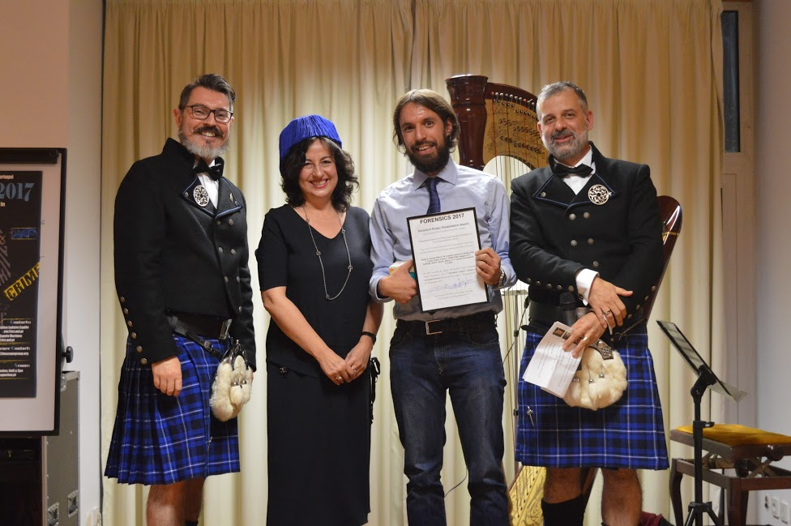

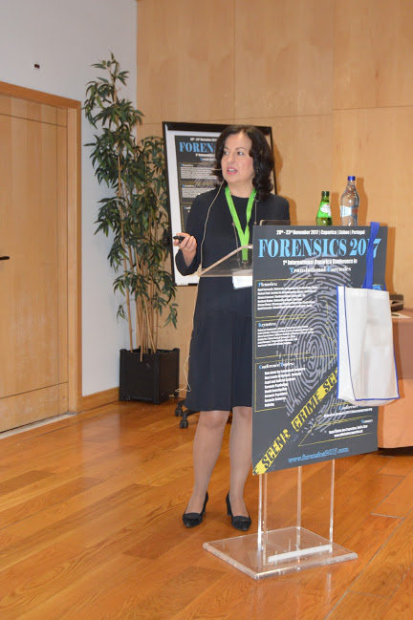
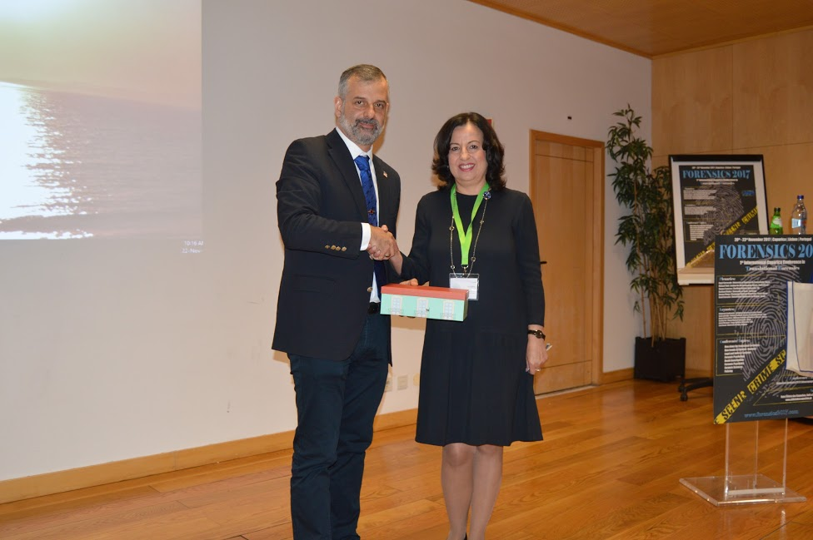

Report prepared by: Prof.dr Simona Francese

